- Distinguish between the terms static stability and dynamic stability. (2 marks)

- Sketching where appropriate, curves showing the kind of motion that might exist, discuss which of the following are possible:
- An aircraft that is statically stable but dynamically unstable.
- An aircraft that is statically unstable but dynamically stable.
- An aircraft that is both statically and dynamically stable.
(3 marks)

- The pitching moment of an aircraft is given by the equation:

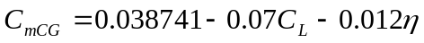

Where is in degrees.
Using the data given below, plot a trim curve (i.e. elevator angle to trim against EAS) for this aircraft for an EAS range from stalling up to 200m/s. Take sufficient intermediate points to define the curve clearly.
(10 marks)

Additional data:

Aircraft weight W=150 KN
Wing area S=37 m
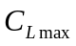=1.25
Assuming sea level conditions 